Multicultural Field Work: In-Person, Fall 2024
September 9/10* – 24th, 2024
www.Fourseasonsleadership.com
- Learn and work within 3 cultures: American, Japanese, and Native American
- Increase English language proficiency and build self-reflection skills
- 2 weeks living with an American home stay family
- Share your Japanese culture with others while they share theirs with you
- Provide Community Service, create crafts, shop locally
September 9/10-24, 2024
$1,900* plus airfare
- Learn about yourself
- Enjoy nature
- Self- reflection gained through community service with children
- Explore meaningful acts of kindness and how those experiences relate to your life.
*subject to change if necessary.
*dates are chosen by best Japanese airfare costs and times
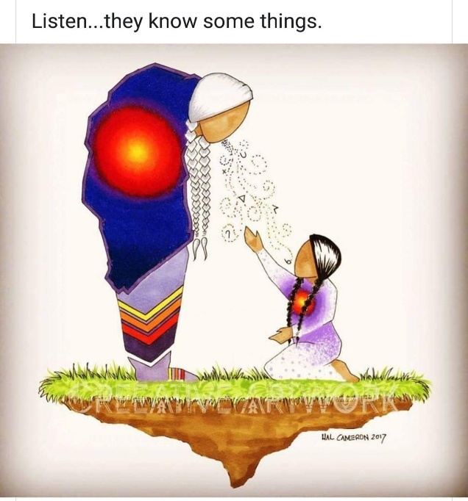

For questions and additional information please contact:
Dr. Judy Cressey
jcressey@msn.com

